EV Coaching Gauge – PHEV_FHEV

Functional Description

The instrument cluster shall filter and display the vehicle power the driver is requesting for propulsion (tractive effort) and the power threshold for when the vehicle will exit/enter "Electric Mode" based on this power demand.

The instrument cluster shall also display vehicle power for deceleration and regenerative braking threshold.

During Deceleration if vehicle power is completely within the regen threshold then this indicates that no friction braking is utilized.

The intent of this is to allow the customer to modulate the accelerator pedal to keep the engine off (and hence improve Fuel Economy) and also modulate the Brake pedal to avoid using friction brake.

Interfaces

Interface Context Diagram (I/O Block Diagram)

EV Coaching Gauge

Inputs

IR-REQ-345040/A-INTERNAL

Operational_Mode

MUX Signals on ICAN bus

SIG-REQ-345041/A-EffRgnThres_Pc_Dsply Signal Details*

Signal Name | Size (bits) | Detail | Units | Res. | Offset | State Encoded | Min | Max
EffRgnThres_Pc_Dsply | 10 | Threshold Power Level to Enter/Exit Regen Mode | % | 0.1 | -102.3 |  | -102.3 (0x0) | 0  (0x3FF)
*** Signal values below -100% are to be treated as Min Cap(-100%)

SIG-REQ-345042/A-EffWhlLvl2_PC_Dsply Signal Details**

Signal Name | Size (bits) | Detail | Units | Res. | Offset | State Encoded | Min | Max
EffWhlLvl2_PC_Dsply | 10 | Driver Requested Vehicle Power | % | 0.2 | -102.2 |  | -102.2  (0x0) | 102.4 (0x3FF)
**This is a signed signal.
Signal values from 0x0 through 0xA are to be treated as Min Cap (-100%)
Signal values of 0xB through 0x3F3 map to 0% through 100%
Signal values from 0x3F4 through 0x3FF (i.e. above 100%) are to be treated as Max Cap (100%)

SIG-REQ-345043/A-EffWhlThres_PC_Dsply Signal Details***

Signal Name | Size (bits) | Detail | Units | Res. | Offset | State Encoded | Min | Max
EffWhlThres_PC_Dsply | 10 | Threshold Power Level to Enter/Exit EV Mode | % | 0.1 | 0 |  | 0  (0x0) | 102.3 (0x3FF)
*** Signal values above 100% are to be treated as Max Cap(100%)

SIG-REQ-345044/A-EngMdeMsgTxt_D_Rq Signal Details

Signal Name | Size (bits) | Detail | Units | Res. | Offset | State Encoded | Min | Max
EngMdeMsgTxt_D_Rq | 3 |  | SED | 1 | 0 |  | 0 (0x0) | 7 (0x1)
 |  | Not Received |  |  |  | 0x0
 |  | EV |  |  |  | 0x1
 |  | Hybrid |  |  |  | 0x2
 |  | Glowing C |  |  |  | 0x3
 |  | Charge |  |  |  | 0x4
 |  | Not Used |  |  |  | 0x5
 |  | Not Used |  |  |  | 0x6
 |  | Not Used |  |  |  | 0x7

Outputs

IR-REQ-345045/A-INTERNAL
Prcnt_Requested_Power
Prcnt_Threshold_Power

IR-REQ-345046/A-External

Requested Power indication
EV Threshold Power indication
Regen Threshold Power indication
Engine Mode Text

Function/Performance

F-REQ-345047/A-Operational Modes
Power Indication Operational Power Mode
Mode | Differentiating Vehicle Conditions
Sleep Mode | All gauges are off
Limited Mode | All gauges are off
Normal Mode | All indications are on/off and with the proper values based on the received CAN bus signal
Crank Mode | All indications are on/off and with the proper values based on the received CAN bus signal

Voltage Levels
Refer to the Cluster Features table located in the Operational Modes and Voltage Range Strategies section in this SPSS

Human-Machine Interface

Visual

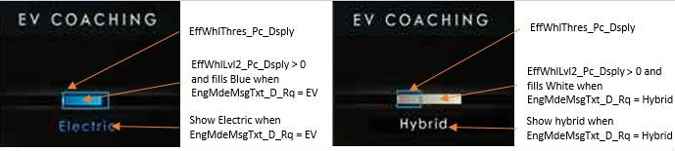

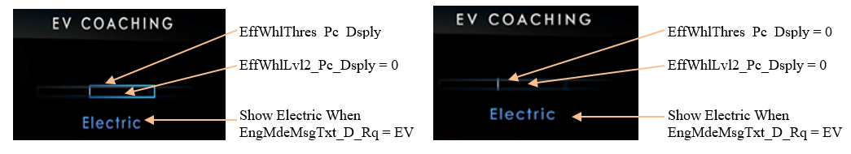

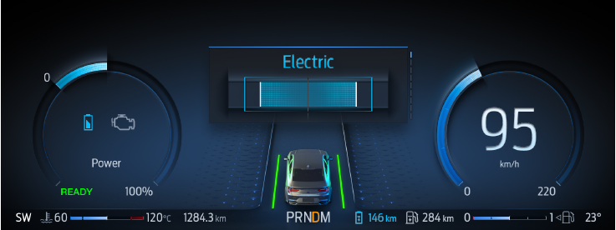
CD542 – Electric (Fill within threshold)

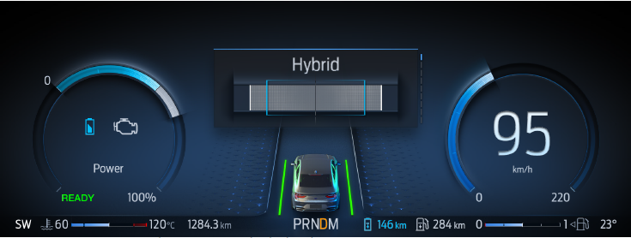
CD542-Hybrid (Fill past threshold or no threshold)
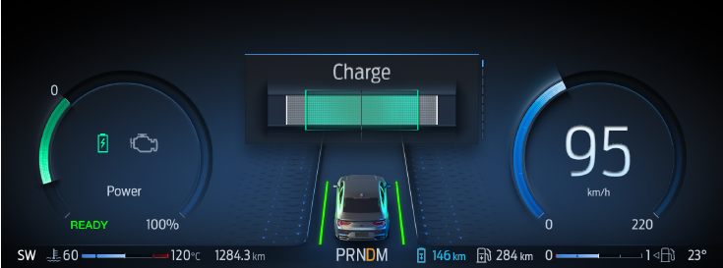
CD542-Charge(Fill Past Threshold)
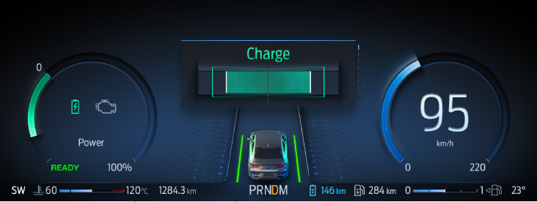
CD542-Charge (Fill with in Threshold)
Note: There is no change in logic and CAN signals for CD542. Only Graphics Update.

Indicator Color Coordinates

None

Indicator Characteristics

None

Audio

None

Switch Control Logic

Not Applicable.

System Accuracy

PFM-REQ-345274/A-Electric mode

The instrument cluster shall display the vehicle power and the Electric mode threshold based on the 0 - 100% inputs from the HPCM. 0% is the bottom of the gauge and 100% the top, with linear interpolation between.

PFM-REQ-345275/A-Regen Mode

The instrument cluster shall display the vehicle power and the Regen threshold based on the -100 - 0% inputs from the HPCM. -100% is the bottom of the gauge and 0% the top, with linear interpolation between.

PFM-REQ-345276/A-Response Latency

The Power Gauge response latency shall be equal to or less than 300 msec for all increasing or decreasing engine speed, where rate-of-change is equal to or less than 100% of scale/second when in Normal or Crank Modes.

PFM-REQ-345277/A-CAN Sampling Rate

The CAN Signal shall be sampled periodically at least once every 100 mS when in “Normal” Mode. Supplier must insure update rate fast enough to insure all performance requirements are met.

Operation: Performance and Functional

F-REQ-345048/A-Subsystem Algorithm Flowchart / State Diagram

F-REQ-345049/A-EffWhlLvl2_PC_Dsply Missing Behavior

F-REQ-345050/A-EffWhlThres_PC_Dsply Missing Behavior

F-REQ-345051/A-EffRgnThres_Pc_Dsply Missing Behavior

Operation Description (supports algorithm flowchart /state diagram)

F-REQ-345054/A-EV Coach Display State Matrix

Operational  _Mode | EffRgnThres_Pc_Dsply | EffWhlThres_PC_Dsply | EffWhlLvl2_PC_Dsply | EV_coach_display
Normal | -100 to 0  (Valid) | 0 to100  (Valid) | -100 to 100 | Gauge will fill linearly based on EffWhlLvl2_PC_Dsply signal value.
Crank | -100 to 0  (Valid) | 0 to100  (Valid) | -100 to 100 | Keep Last  Known value
All other cases |  |  |  | No Fill/Rest

- Valid range for EV Coaching Gauge is -100% to +100%.
- Signal value outside this range will be treated with Min Cap(-100%) and Max Cap(+100%).

F-REQ-345055/A-EV Coach Text State Matrix

Operational  _Mode | EngMdeMsgTxt_D_Rq | EV Coaching  Text
Normal/Crank | 0x1(EV) | Electric
Normal/Crank | 0x2(Hybrid) | Hybrid
Normal/Crank | 0x3 (Glowing Charge) | Charge
Normal/Crank | 0x4 (Charge) | Charge
All Other Cases |  | None

Note: For Gauge Fill color, Text and Text color please refer program specific HMI specifications.

F-REQ-345056/A-EV Coach Threshold Box Color Matrix

Operational  _Mode | EffWhlLvl2_PC_Dsply | EffRgnThres_Pc_Dsply | EffWhlThres_PC_Dsply | Regen Threshold Box | EV/Hybrid  Threshold Box
Normal/Crank | -102.2 to <0 | -102.3 to 0 | X | Yes (Green) | No
Normal/Crank | >=0 to 102.4 | X | 0 to102.3 | No | Yes (Blue)
All Other Cases |  |  |  | None | None

F-REQ-345271/A-CAN Sampling Rate

The EV Coaching Gauge shall sample the CAN Signals periodically at least once every 100 mS when in “Normal" or "Crank" Mode. Supplier must insure update rate fast enough to insure all performance requirements are met.

F-REQ-345268/A-Smooth Pointer Movement

The EV Coaching Gauge must track all dynamic power requests with a smooth pointer movement with no greater than 300 millisecond lag and an overshoot/undershoot not to exceed 2% of full scale.

F-REQ-345269/A-Pointer Accuracy
The EV Coaching Gauge shall not exhibit pointer waver exceeding 0.1% of total pointer travel range with a steady commanded input.

F-REQ-345270/A-Pointer OFF Display

The EV Coaching Gauge “0, OFF” position shall result in no pointer being displayed.

F-REQ-345272/A-Gauge Filtering for Driver Requested Power & EV Threshold Power

The EV Coaching Gauge shall be initialized to the first valid input values received after:
- A transition to Normal/Crank from Sleep/Limited
- A recovery from the Rest Position for Missing Messages
- A recovery from the Rest Position for Invalid values

Function Safety Classification (EMC)

B

Memory Storage

NVM-REQ-345052/A-Memory Storage Part 1

Parameter Name | Description | Value at Battery connect | Value at  Module Wake-up
Prcnt_Requested_Power | Used to control Requested Power displayed | 0x0 | 0x0
Prcnt_Threshold_ Power | Used to indicate the EV Threshold Power displayed | 0x0 | 0x0
Prcnt_Regen_Threshold_ Power | Used to indicate the Regen Threshold Power displayed | 0x0 | 0x0
EffRgnThres_Pc_Dsply (ICAN) Signal | ICAN signal sent from HPCM for Regen Threshold Power Percentage Value | As per ICAN Message List | Do Not Init
EffWhlLvl2_PC_Dsply  (ICAN) Signal | ICAN signal sent from HPCM for Driver Requested Power Percentage | As per ICAN Message List | Do Not Init
EffWhlThres_PC_Dsply  (ICAN) Signal | ICAN signal sent from HPCM for EV Threshold Power Percentage value | As per ICAN Message List | Do Not Init
EngMdeMsgTxt_D_Rq  (ICAN) Signal | ICAN signal sent from HPCM for Engine Mode | As per ICAN Message List | 0X0
Operational_Mode | 4 state indicator for cluster operational mode | Limited | Limited, Normal or Crank

NVM-REQ-345053/A-Memory Storage Part 2

Parameter Name | Description | Value at  Battery Connect | Value at  Module Wake-up
RequestedPwr_Invalid_Data_Timer | Timer used for Invalid message strategy | Not Active | Not Active
EVThresPwr_Invalid_Data_Timer | Timer used for Invalid message strategy | Not Active | Not Active
RegenThresPwr_Invalid_Data_Timer | Timer used for Invalid message strategy | Not Active | Not Active
MMT_C100_xxx* | Timer used for missing message strategy | Not Active | Not Active
* xxx denotes the message id.

Prove Out

No

Reconfigurable Telltale

No

SR-REQ-345267/A-Error Handling

The EV Coaching Gauge shall return to the “Rest Position” within 1000ms of determining an error condition as defined in section 1.3.5.1 in the Subsystem Algorithm Flowcharts.

Missing Message Strategy

Each of the received signals will be declared missing as per the Diagnostics section of this SPSS.

DTCs states and history will be determined as per the Diagnostics section of this SPSS.

Diagnostics

Self Test

None

Engineering Test Mode

None

Part II Performance

DTC-REQ-345039/A-Supported Diagnostic Trouble Codes (DTCs)

DTC | Description
C29300 | Lost of Communication with HPCM

Reference Specification

Manage EV

CAN Database

Subsystem Specific Diagnostic Specification (Part 2)

Diagnostic Fault Coverage and DTC Numbers Design Considerations

Revision History

STSS Module Revision History

Revision Level | Name | Change Description | Date
1.0 | H. Sharma | Initial Release | 12/04/2017
1.1 | H. Sharma | In this STSS update DTC #C59486 logging is removed for CAN signals invalid values, corresponding flow charts also updated. Updates are marked in Bright Green Color. | 06/11/2018
1.2 | H. Sharma | Initial RM VSEM Release | 02/22/2019
1.3 | H. Sharma | This Change request was brought to DICC by EPE team (Charbel Bouery) and approved offline by Scott Watkins on 02/05/2020. In this update new graphics for CD542 is added for reference and EV coach Gauge fill color and Text requirements are made generic so implementation can follow HMI and use this STSS for reference only. All the changes are marked in Turquoise color. DICC Tracking #494.  - Section 1.2.1 Interface Context diagram is updated to match Section 1.2.3 Outputs.  - Section 1.3.3.1 is updated to add CD542 HMI examples.  - Section 1.3.5.5.2 F-REQ-345055/A-EV Coach Text State Matrix is updated to simplify color and Text requirement. | 03/09/2020

